Welcome to the Jill Novak Yoga Mexico Retreat Guide.
This guide is meant to help you decide if this retreat is indeed for you. There are lots of different ways to invest your time and money out there, we respect that. We hope this helps you make the right choice.
This 5 day/6 night retreat is an incredible experience in connection, re-patterning old stories, and creating a clear vision for your future, one small easy step at a time. We are serious about Yoga and Ayurveda, we sync with the rhythm of the day to guide our practices. You will go home feeling satiated. Full and Juicy, not like you partied all week and now need a vacation to recover from your vacation.
Co-hosting the retreat this year is Play Professional, Tracy Paley, ensuring that we allow time and space for laughter and lightness even when we are getting serious about self discovery. As children we played all the time, somewhere along the line we got serious and stopped playing. Our goal in this retreat is to bring back play. Your task is to arrive with an open mind, and willingness to tap into your inner child, throw caution to the wind and remember what it feels like to play. Laugh, be silly, and do things even if they aren’t “productive” in our adult brains.
We spend our morning in practice and our afternoons in play.
We wake with the sun, and sleep with the stars.
We let everything fall away that is not necessary and sink into deep self connection.

When Are We Going? 1
Flights 1
Transportation 1
Accommodations 2
Daily Rhythm 4
Workshop Themes 5
What should I bring? 5
FAQ’s 6
Dosha Quiz 10
How to Plan Before you Come 10

When Are We Going?
Monday March 7th to Sunday March 13th

Flights
Sayulita is located on the Pacific Coast of Mexico in the state of Nayarit, 40 miles from Puerto Vallarta Airport. The retreat starts Monday evening and ends Sunday by noon - plan your travel accordingly.
Often people stay a couple extra days or come early.
Fly into PVR Airport (Puerto Vallarta).

Transportation

All we require is a shuttle to the hotel, after that we travel by foot alone (talk about grounding!) If most people are flying in on Monday, we will arrange a group shuttle to get us to Sayulita.

If you plan on arriving a few days early or staying a few extra days you can easily catch a cab to Sayulita. The drive is 40 minutes. It's about $50-$75 USD for a car or van... Catching a cab on the other side of the overpass is about half the price ($30 USD). Cross the highway on the walking bridge outside the airport and go up and over. Tip your cabbie.

Accommodations
Hotelito Los Suenos is a quaint boutique hotel with the most loving and supportive staff. We book rooms with 2 Queen Beds and a balcony. Each room has a fridge and a purified water dispenser. There is air conditioning and a fan in each suite. We price and plan for double occupancy.
- If you are interested in having a private room we can book a Superior or Premium. The additional cost for a private room is $250.00
- If you want to book a room that sleeps 4, we can do it, if we book soon enough.
Breakfast is prepared for us each morning on the third floor kitchen with the palapa roof shading us from the sun. Breakfast is local fruits, fresh squeezed juices and a new buffet every day featuring things like eggs, beans, potatoes, daily baked bread and homemade jam, pancakes, and skillet veggies. Coffee and tea of course.
There is a hot water tap in the kitchen for easy access to make tea or hot lemon water at any time.
Our Yoga is in the open air shala, equipped with mats, blocks, bolsters and blankets to enhance our practice. You can bring your own mat if you are attached to it, but no need if you are happy using the ones provided.
The front desk has pool towels for your afternoon rinse off in one of their two pools.
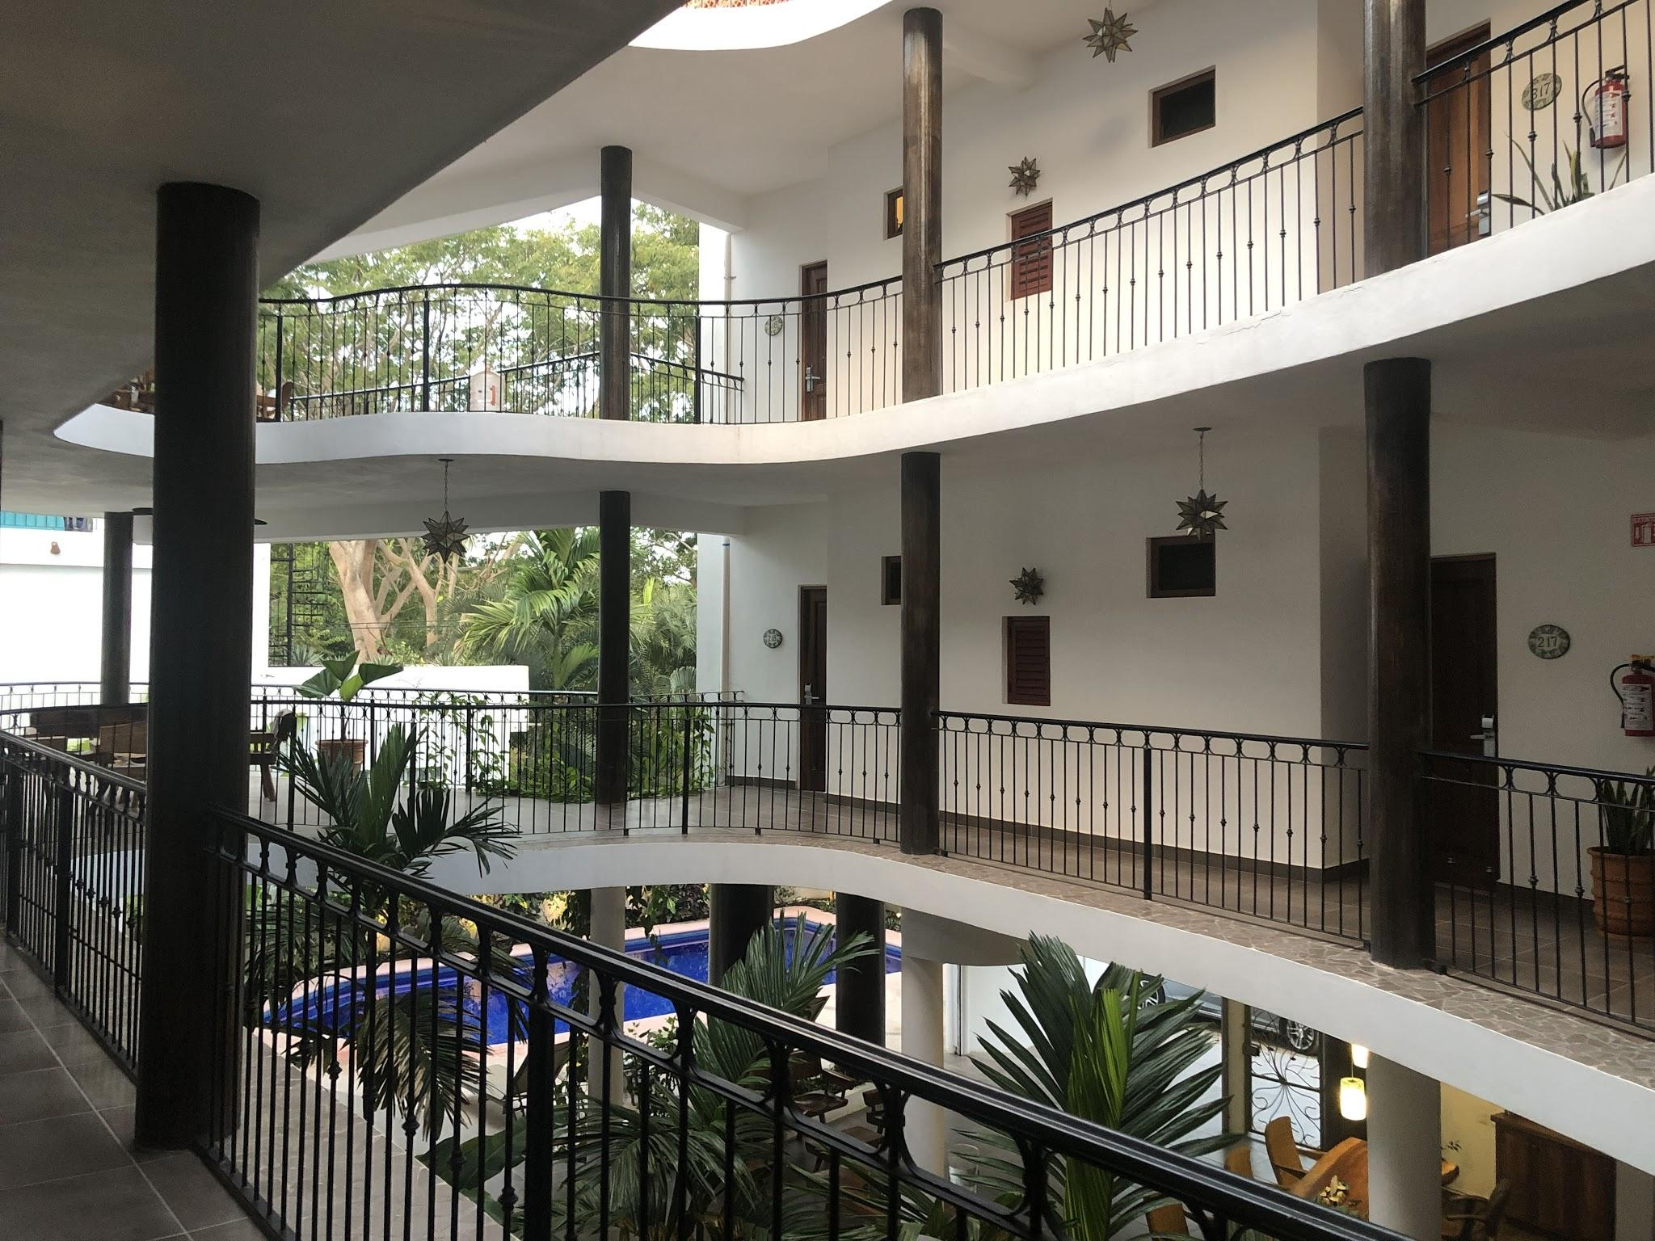
Adriana is our on-site host, although we find that all the staff are so friendly. Your retreat price includes tipping. We will ensure that the staff is taken care of. 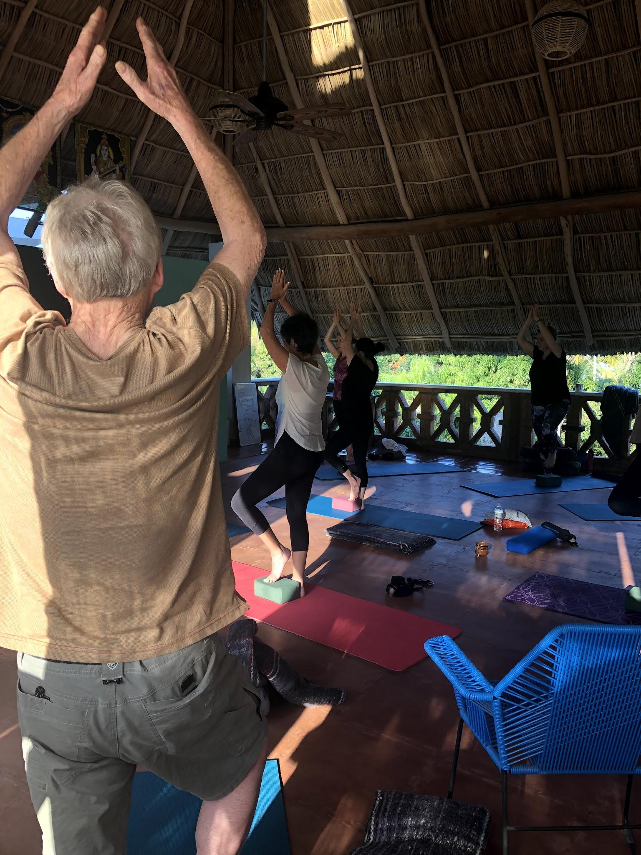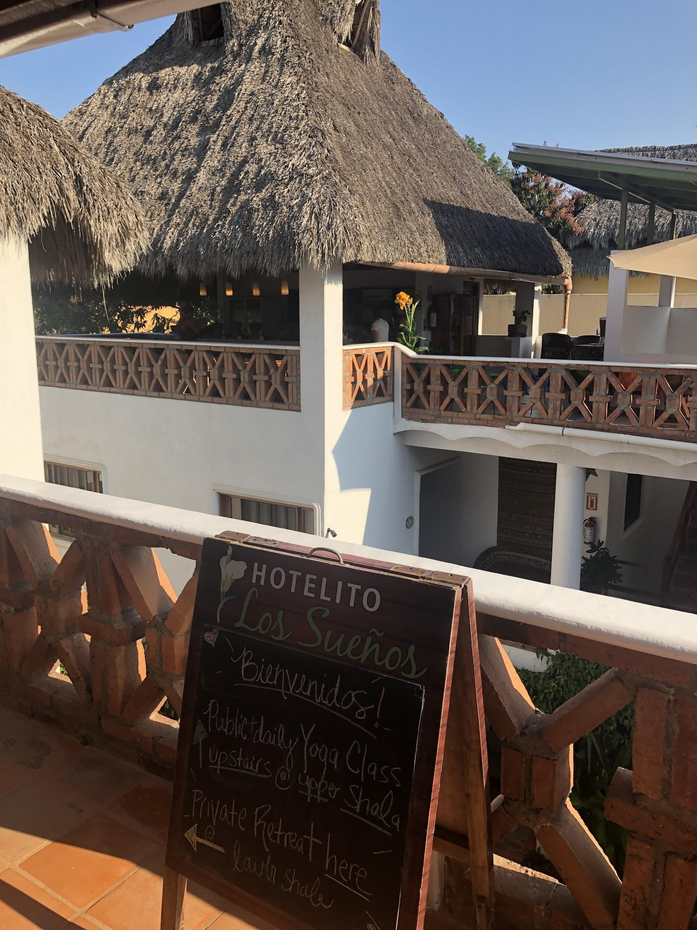

Daily Rhythm

Our schedule runs a bit like this: Yoga fills our mornings, and sunshine and play fills our afternoons. We keep it simple, rise early, get to bed early. We nourish our sleeping and eating patterns for great rejuvenation. The goal is to have you return replenished.

Lunch and Dinner are not included in the retreat price. We did this to maximize our options for exploring the local dining. The food is amazing and well priced, you can eat for under $10 a meal if you choose, you can splurge for $20 and have an amazing meal.
7:00am - 8:00am
Meditation and Journaling on the Beach (sunrises 7:30am)
8:00am - 9:00pm
Morning Movement in the Yoga Shala
9am -10am
Breakfast

10:00pm - 12:00pm
Morning Workshop
12:00pm - 1:30pm
Lunch
1:30 pm - 5:30pm
PLAY time
DOWN time FREE time

5:30pm - 8:30pm
Dinner
Walk the lively streets, watch the sunset (7pm), get an ice cream, mellow out

9:00pm
Evening Yoga Nidra and Early to Bed

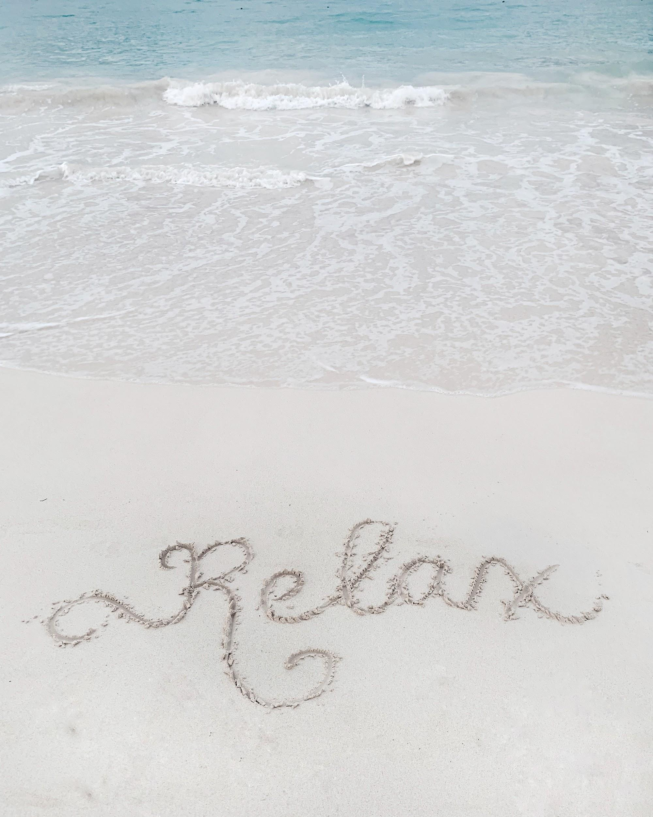
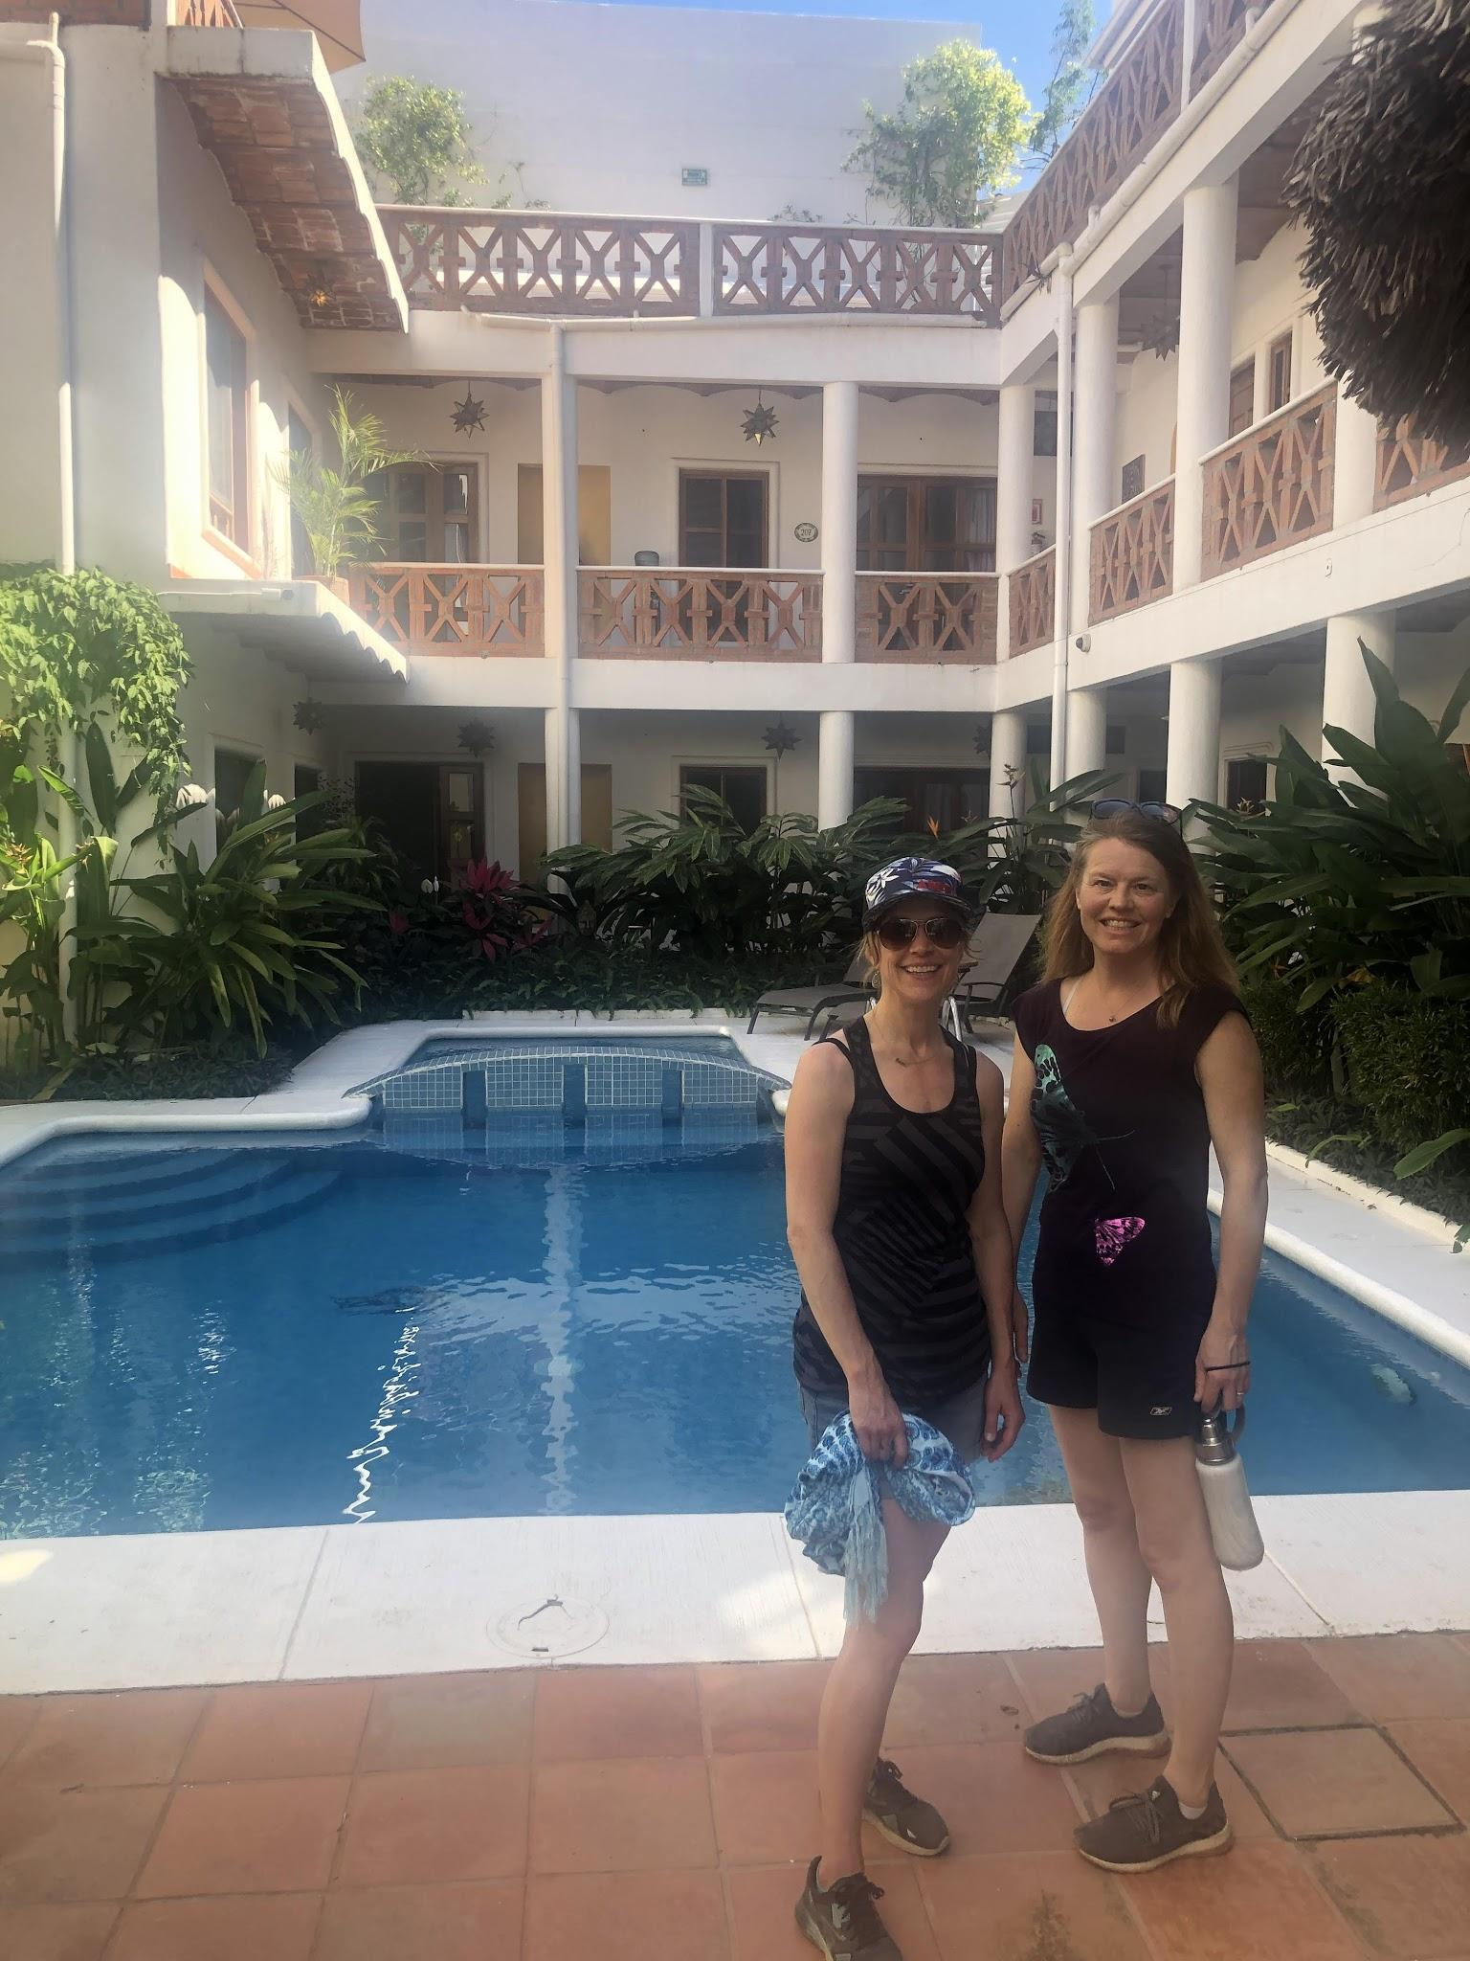

Workshop Themes

This year we will cover the 5 elements: Earth, Water, Fire, Air, and Space. You will have some elements more prominent in your constitution that naturally support you and some that you will need to tend to more to feel their nurturing properties.

To get a sense of this you may want to read this blog post Unlocking the Truth in your Natural Elements. Each day we will do exercises to get you clear on how you can find efficiency and support from each element. Fascinating Juicy Stuff.

What should I bring?
- Your journal/blank notebook (something to write on that is not electronic)
- Colored pens/markers/pencils
- Your bathing suit, flip flops, and a wrap.
- Non-toxic Sunscreen
- Water bottle to refill in your room as often as you need.
- Light summer clothes
- Sunglasses and hat
- Yoga clothes
- A warmer layer for the cool evenings and mornings.
- A light easy to pack rain jacket (hopefully won't need it)
- Yoga towel/mat for the beach if you like. I use a turkish towel, and in the last two year people have purchased a light shawl on the beach that serves our purposes.
- Mexican Pesos for local purchases. The restaurants will accept credit cards and US$, but many of the local vendors will just take Peso’s. You can easily exist on Pesos and your credit card alone.

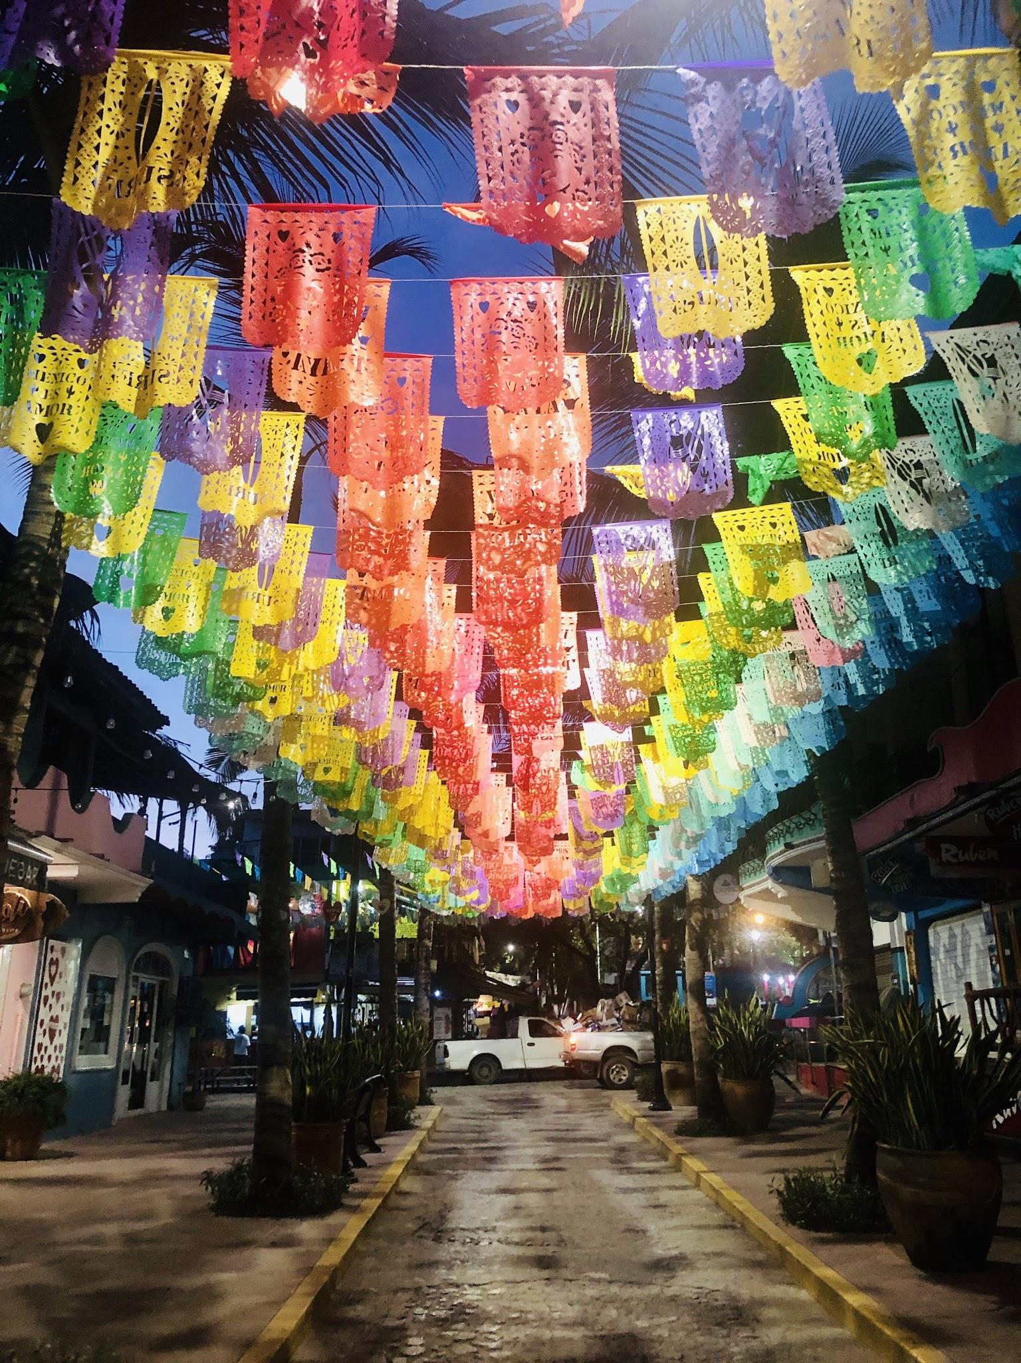
FAQ’s

Q: What will we be doing in the workshop sessions?
A: This year we will focus on the ways we can create meaningful change through the lens of the Earth Elements. Understanding our unique constitution and how we can support our growth with purposeful practices is our goal.

It is transformational stuff and I can’t wait to share it with you.

PLUS: Fingers crossed Jill will be fresh off her own immersion experience with her teacher Cate Stillman, busting with new ideas.

Q: What is the refund policy if something happens and I can’t come.
A: I get that life changes. My deal is that if I can get a refund, I can give a refund. The hotel requires full payment 45 days ahead of time. So until that point I can refund you. At minimum, there will be a $100 non-refundable deposit to cover all my stupid little costs like Credit card fees, insurance, etc.

Q: What will I get out of the experience?
A: You can expect to experience deep connection. You can expect to have a personal breakthrough or two. Yes, there will be time to walk the beach, explore the town, journal by the water, get a massage, hang by the pool, and play....

Q: Should I bring pesos with me?
A: If you’re not experienced in foreign travel, it is recommended that you exchange some money (I bring about $500CDN in pesos) into pesos BEFORE you leave home. You’ll have one less thing to worry about on the airplane.
Nicer restaurants and taxis accept credit cards. However, you’ll want pesos for the beach to buy a coconut, a sarong, or a drink on the beach (KIDDING - no buying drinks on the beach). There are ATM machines at the corner convenience store, but easy to get pesos at your bank at home and save yourself the hassle.

Q: What will we eat?
A: Dinner and Lunch are on your own and not included in the retreat price, although we still find ourselves eating together. Each night we pick a new restaurant and let everyone know the meeting time. There are many great local restaurants. The food is relatively in-expensvie. The Mexican food is abundant, delicious and cheap. There is a fantastic pizza place, great coffee shops, and amazing ice cream vendors. We eat at “nicer” seafood and italian places once or twice.

There are small grocery stores throughout town, and your room has a fridge for you to store whatever goodies you want close at hand.

Q: Are the beaches rocky or sandy?
A: All the beaches are beautiful and sandy. The main busy beach we walk often, lots of vendors hawking their wares, local restaurants, and open air massage tents.

The beach of the dead, Los Muertos, is a short walk through a graveyard. One year we found this beach deserted and quiet. One year it was busy.

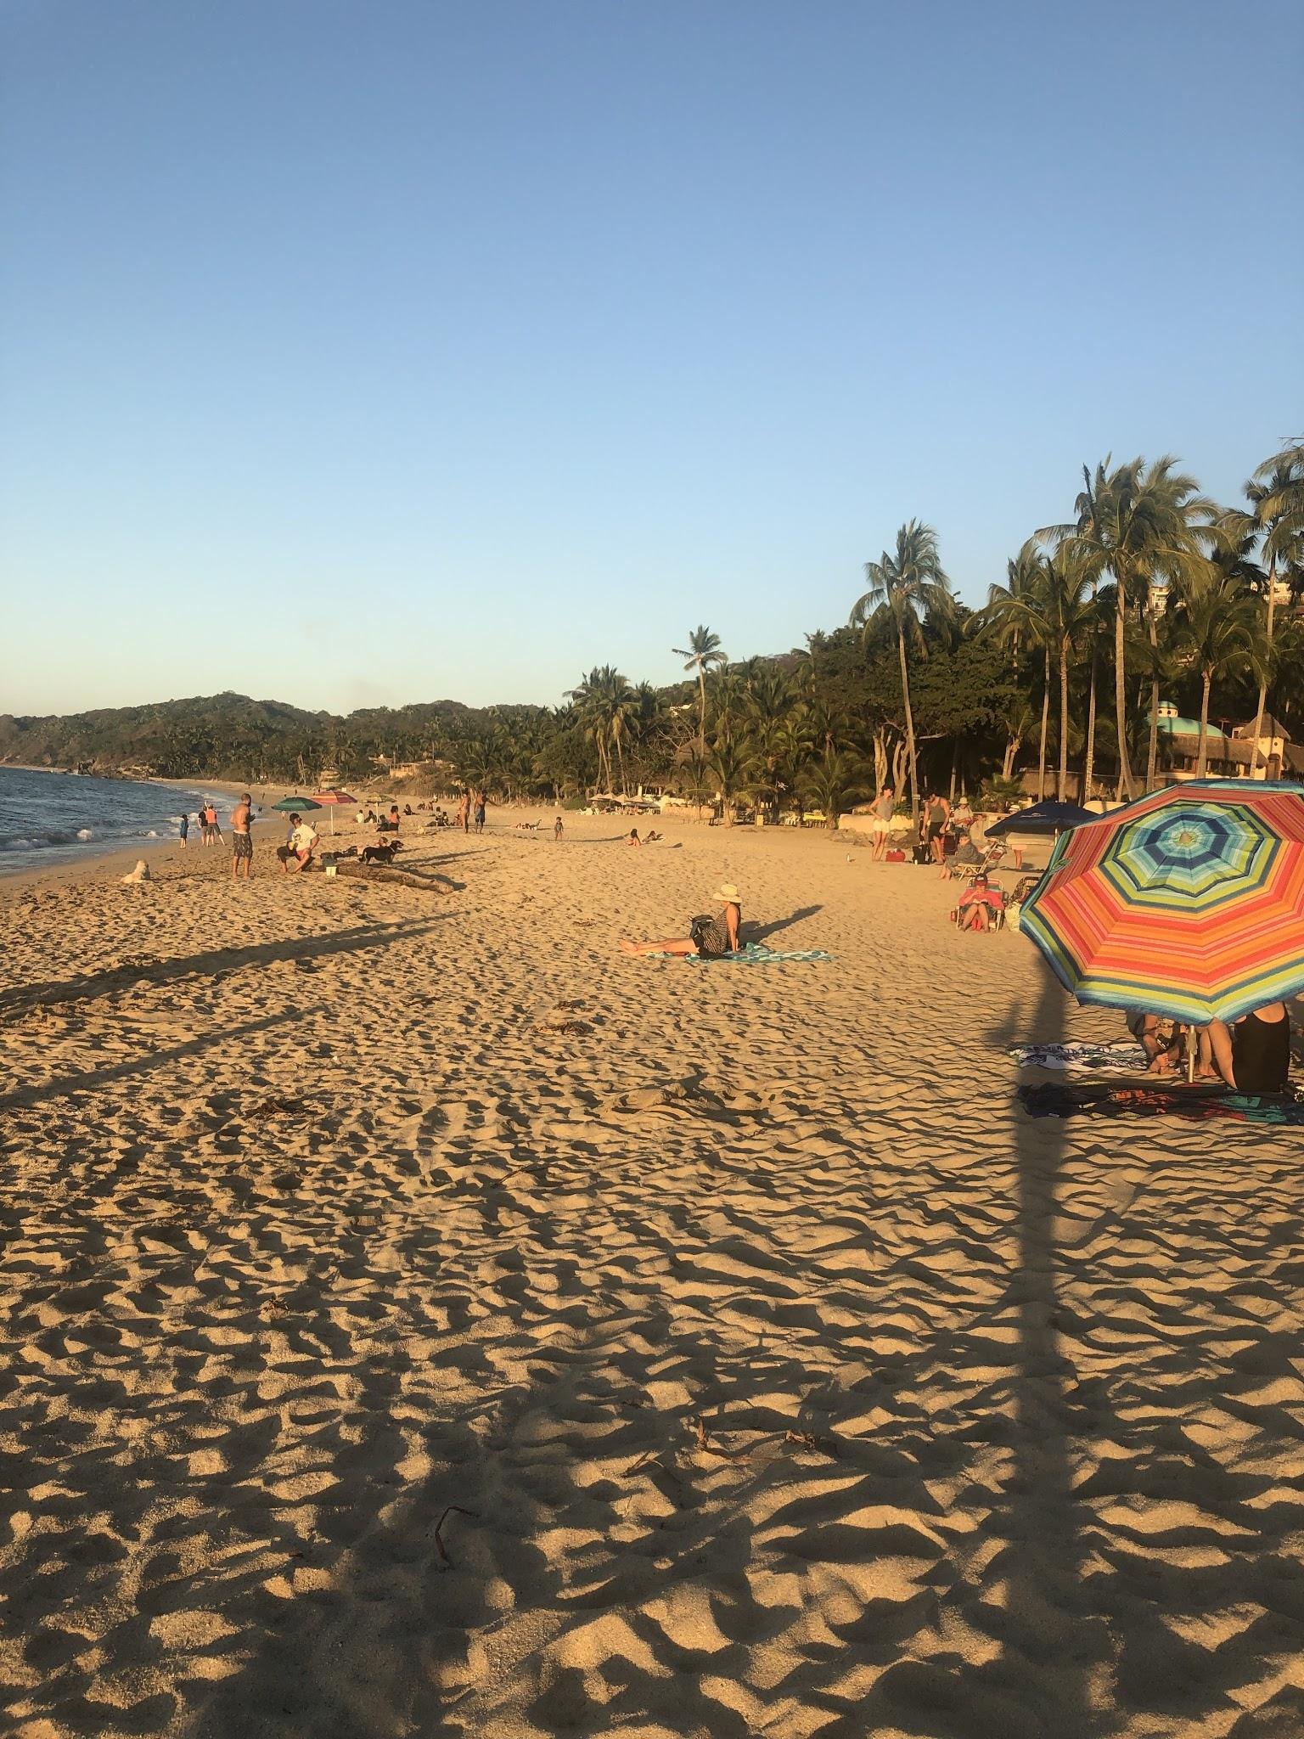
We discovered a beautiful short hike to Los Cuevas Beach on the north side of Sayulita, just up from our hotel. We hike here with our beach towels and water bottles to play in the ocean, build sandcastles and create nature art.
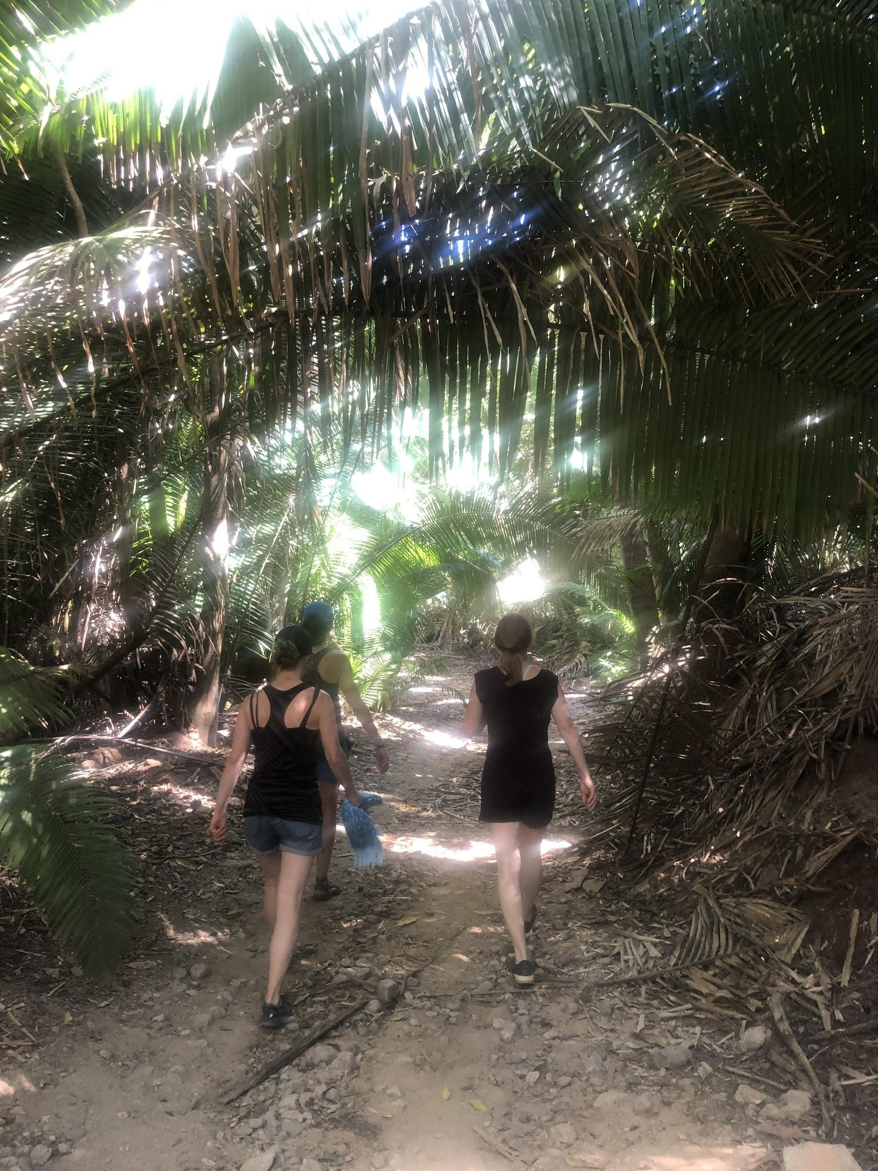
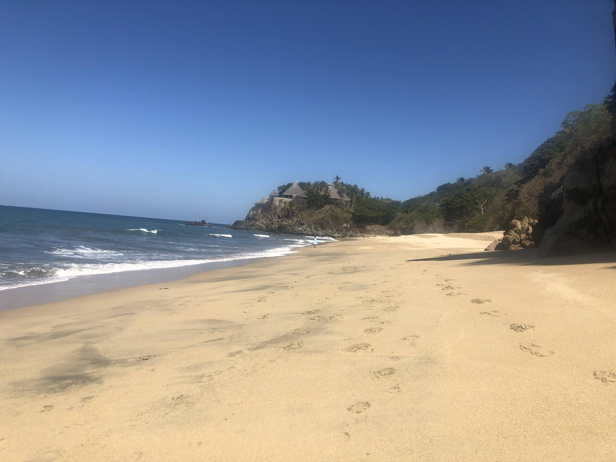

Q: What happens during free time?
A: There is so much to see and do in Sayulita. There is an amazing little Hippie Market, used book store, and Organi-k Smoothie spot on our way to the bustle. The town itself is a gem, packed with galleries, shops, and restaurants. Often live street entertainment and unexpected photo ops, like the little shop with the wings.
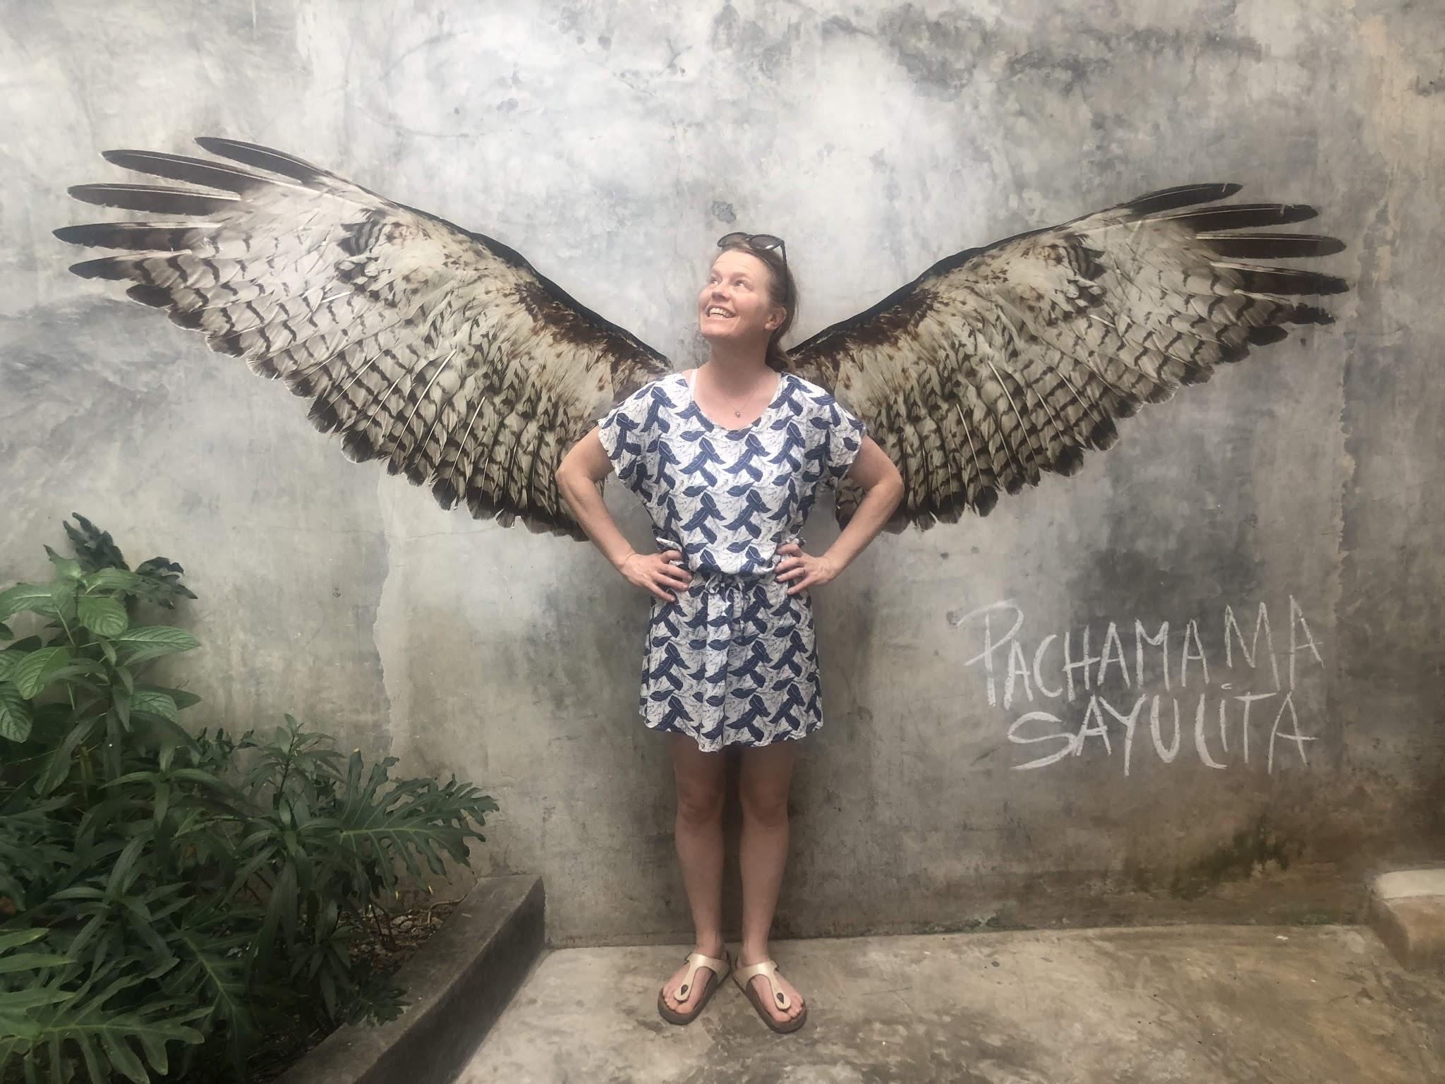

Q: Should I book more time than just 6 nights?
We do not book any excursions because the timing interrupts our rhythm a bit too much. If you want to plan an extra day or so I can promise that a trip to Marietas Island is well worth it. The whale watching is fantastic, the island is stunning, the snorkelling is good (but not stunning if you are fussy). Nearby Punta Mita has great more upscale restaurants right on the beach.

Q: What if I get sick?
A: Well honestly, the chance exists. We learned our lesson and will not be ordering drinks off a random guy making them out of his cooler on the beach. We will check in with our hotel staff on the reputation of each restaurant we choose, drink only purified water, and take any precautions we deem necessary. No one got sick at all in 2020.

Explore Sayulita online a bit more if you like.
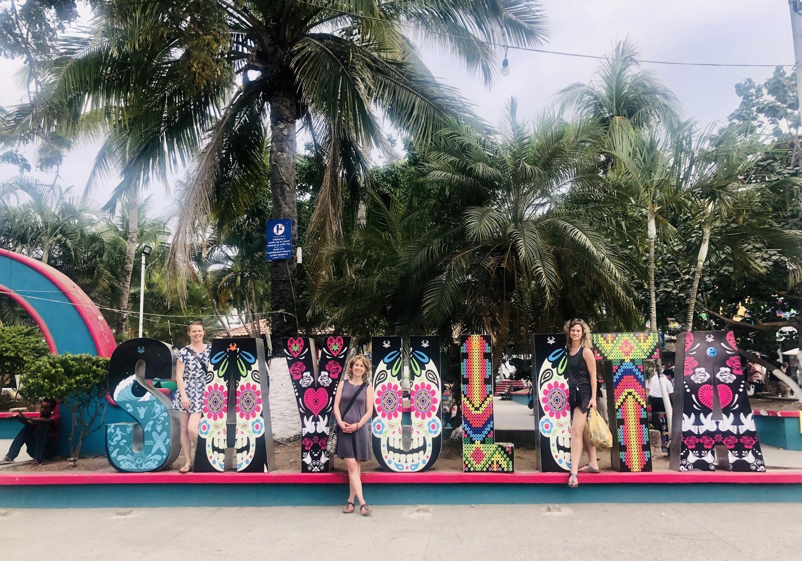

Dosha Quiz
Awareness is the greatest agent of change they say. So let’s dig in, when we see ourselves clearly we can capitalize on the stuff that we don’t need to keep doing, and lean into our innate wisdom.

- Your Ayurvedic Constitution Quiz

If you want to dive into this deeper with me before the retreat. Feel free to book a one hour Ayurveda Constitution Assessment before we go. If you are brand new to Ayurveda, this can be a hugely helpful step. If you have taken the Year of YOU or Fireweed Yoga Teacher Training then you have the base knowledge that you need.

How to Plan Before you Come

YOU want to arrive in peak condition. You don’t want to be tired, constipated, or sick. Don’t cram two weeks of work into one and show up drained and exhausted.
- Plan ahead - make a list, order your pesos, buy sunscreen, and any over the counter supports you like to travel with (gravol, tylenol, etc).
- Prioritize Your Growth - show up to the group with wholehearted presence.
- Get organized.
- Drink your green juice + eat your beets and let your body poop every day. Travelling can be constipating, so at least clean out those bowels before you arrive.
- Take your Dosha Test. Start to get a grasp of your constitution.

Tracy and I believe that the universe chooses who comes.

With this document we are trying to be as clear as possible about what this retreat is about, and create the best probability for the perfect people to sign up.

We have had ages women 34 - 71 attend. Our token male has been Jill’s father (who was 81 years old when he came) .

We have had mothers and daughters, sisters, friends, and totally solo people join. They have come from my yoga classes, parents from the kids sports teams, from my family and friends, and the greater community. It has always turned out.

If there is anything else that we failed to cover here, just shoot Jill an email. This is our third year heading to Sayulita. We learn more every year and we evolve differently each time.

Looking forward to seeing who the universe assembles this year.

Love
Jill and Tracy.

jill@jillnovakyoga.com

